1. Class Diagram

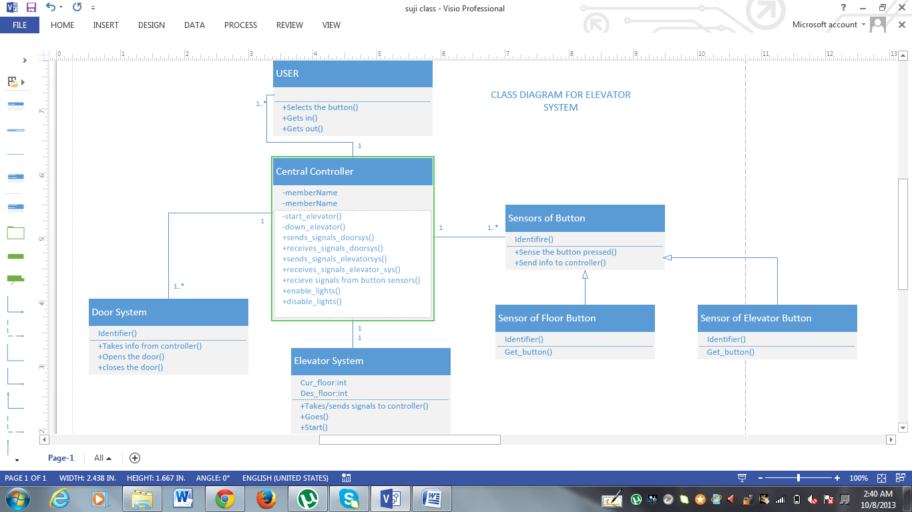

Above is a class diagram of the elevator system and is described as follows

USER

This class is designed so as to show the activities usually done by the user. He clicks the intended button, gets in and gets out at desired floor.

Central controller:

This is designed to manage the whole control of the elevator system. It looks after every activity that occurs in the system. Sends signal to elevator to reach move in either upward or downward direction. As system is aimed to act as a whole to make user feel the way he uses the elevator system. Controller sends and receives signals from the door system and elevator system. Prominent function is the way lights are lightened in the elevator. As user clicks the button lights must be illuminated and turn off once done with the purpose.

Door System:

This class is designed with a mere aim of allowing the elevator to respond accordingly. As person clicks on the elevator button it reaches and the way it reaches it must open door for him and close as he enters the elevator. After moving the lift in the direction of user’s intention door system must see that door opens for him and gets closed the moment he leaves the lift.

Elevator System:

This class takes responsibility of current elevator’s position and move in the direction as signaled by the central controller. Once it reaches the floor it sends control signal to the system. When and where elevator must halt is also decided by this class.

Sensors of the button:

Buttons are the major element of the elevator system. The play of the elevator system whirls around the buttons. This class is a super class of the 2 child classes’ floor and elevator.

Sensor of Floor button:

This sub class inherits features of the parent class sensor of the button. Identifying the button clicked. Sense the clicked button and send signal to the appropriate controller.

Sensor of elevator button:

This sub class inherits functionalities and properties from its parent class sensor of the button. Elevator usually has the number of buttons same as the number of floors. Whereas floor has just two or one.

1. Sequence diagram:

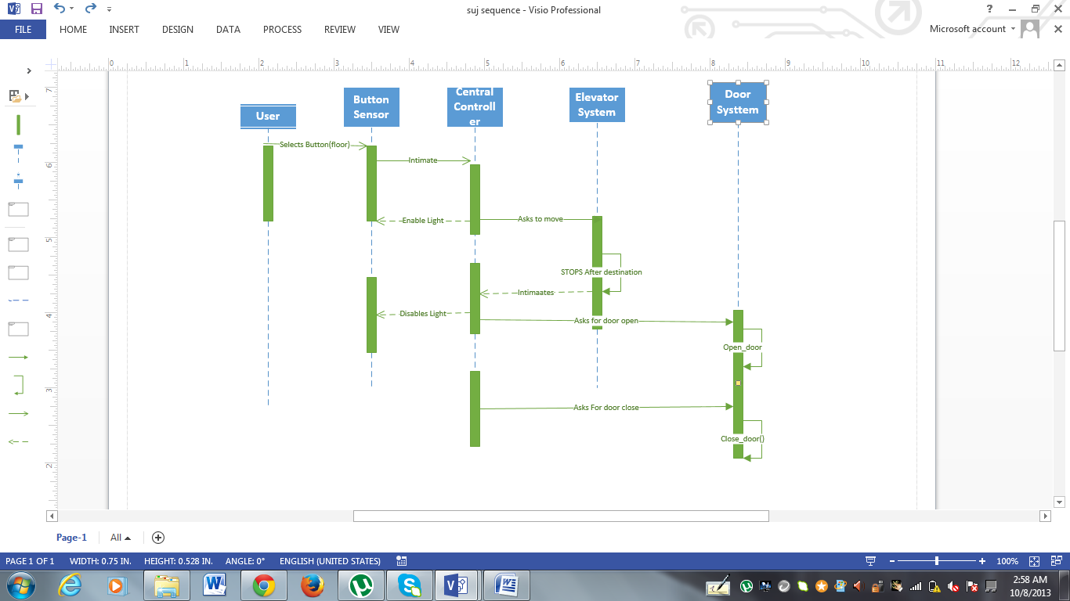

Above is a sequence diagram that represents the functionality of the entire system.

User reaches to the elevator system and clicks the floor button. Button sensor senses the click of the button and signals the controller. Besides enabling illumination of the button it also signals the elevator system which then brings elevator to the user’s floor if not on the user’s floor. As user gets in and clicks the button, Button sensor again comes into action so as to check the clicked button and make user reach the corresponding floor. Stops on the floor and intimates the controller. Controller turns of the illumination of the button and pings door system to open the door. As user exits it senses and closes and remains in the same for next request.

1. Architecture Diagram:

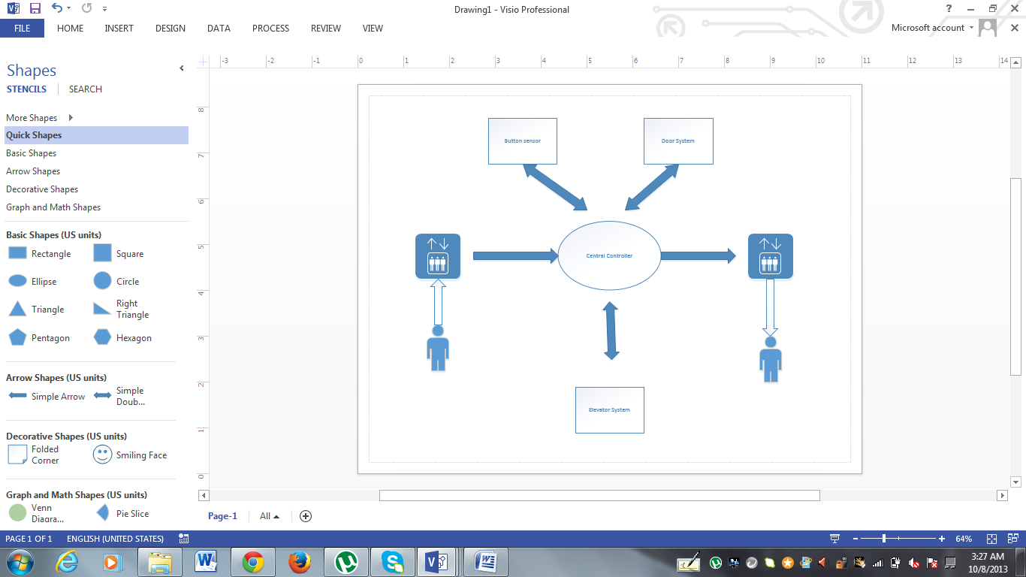

As shown above the Elevator system can be architecturally represented. User moves to the elevator in the floor clicks on the button. Signal is directed to the Controller. Which then takes care of the entire system as it is associated with Door system, button sensor and floor controllers. Controller unites the whole elevator system’s work.